**GOVERNMENT DEGREE COLLEGE, GUMMALAKSHMIPURAM**

**🎭 EVENT REPORT: CULTURAL FEST 2024**

**📅 Date:** 26-10-2024  
**🕒 Time:** 2:00 PM onwards  
**🏛️ Venue:** College Campus  
**🎯 Organised By:** NSS Units I & II  
**👨‍🏫 Guest of Honor:** Dr. T. Sreevaram, Principal  
**👩‍🏫 Lecturers Attended:** 10  
**🎓 Students Participated:** 200

**Objective of the Event:**

The **Cultural Fest 2024** was organized with the aim of **encouraging student talent, promoting cultural heritage**, and **fostering unity and creativity** among students. The event provided a platform for the students to express themselves through various forms of art and performance.

**Event Highlights:**

* The programme commenced at 2:00 PM with an **inaugural address** by the **Principal, Dr. T. Sreevaram**, who lauded the efforts of the NSS Units and emphasized the importance of cultural expression in student development.
* Students actively took part in a variety of **cultural performances**, which included:
  + **Tribal Dance** showcasing local traditions and community heritage
  + **Classical Dance** performances reflecting India’s artistic legacy
  + **Solo and Group Singing** highlighting diverse musical talents
  + **Skit Performances** with social messages and humor
* The vibrant and energetic participation of students turned the fest into a **memorable celebration of art, tradition, and creativity**.
* The entire faculty, including lecturers from various departments, attended the event and **enthusiastically encouraged the students**, adding to the festive spirit.

***Cultural dance by 3rd B.Com students :***

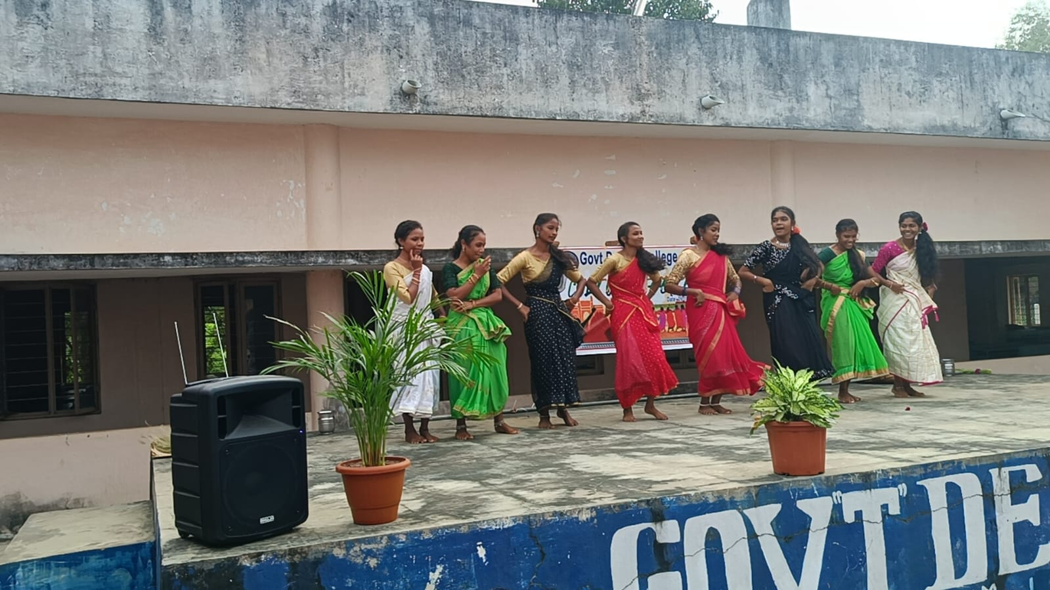

***Classical dance by P. Padmini :***

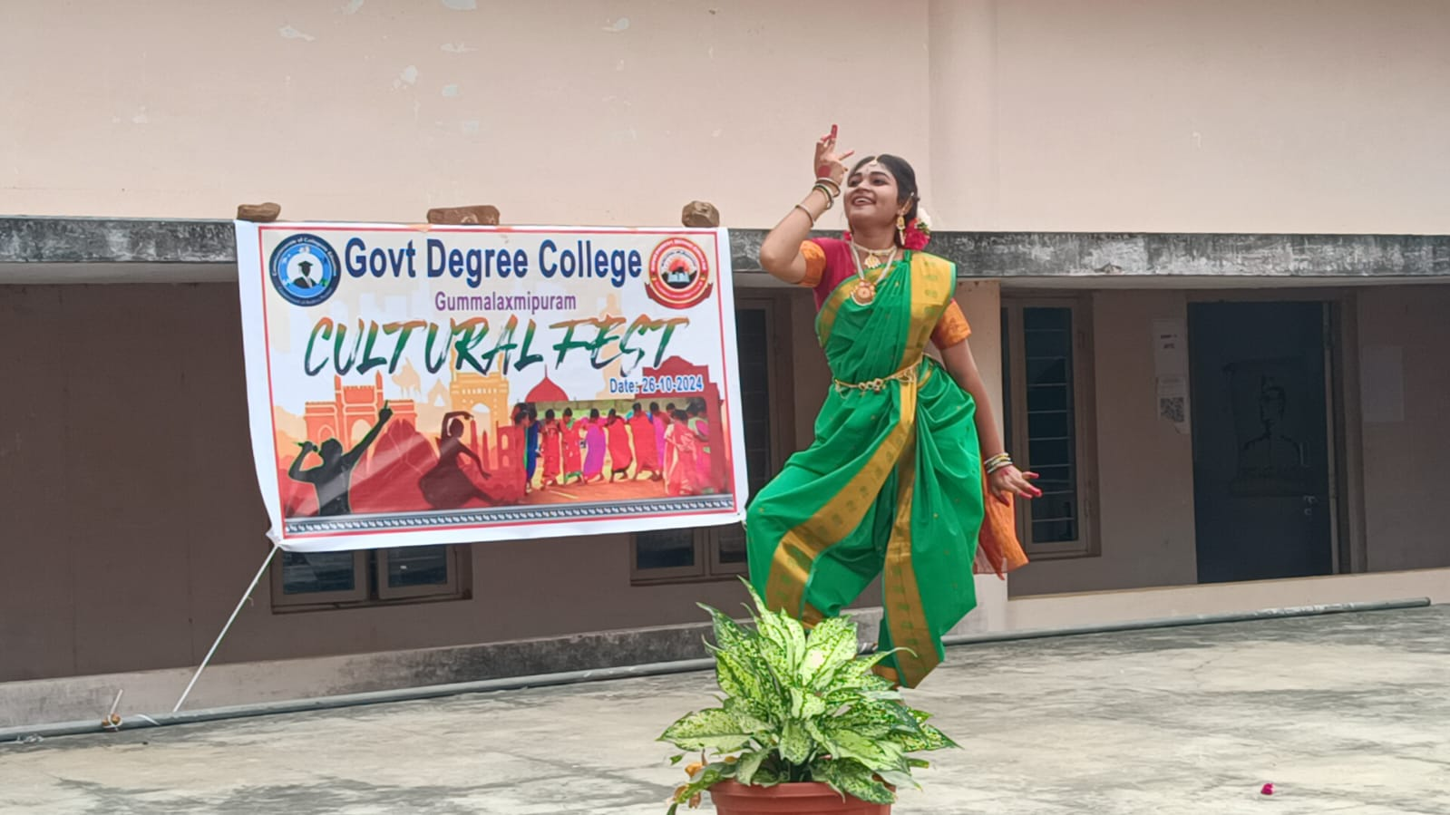

***Skit by 2nd year Political Sciences Students :***

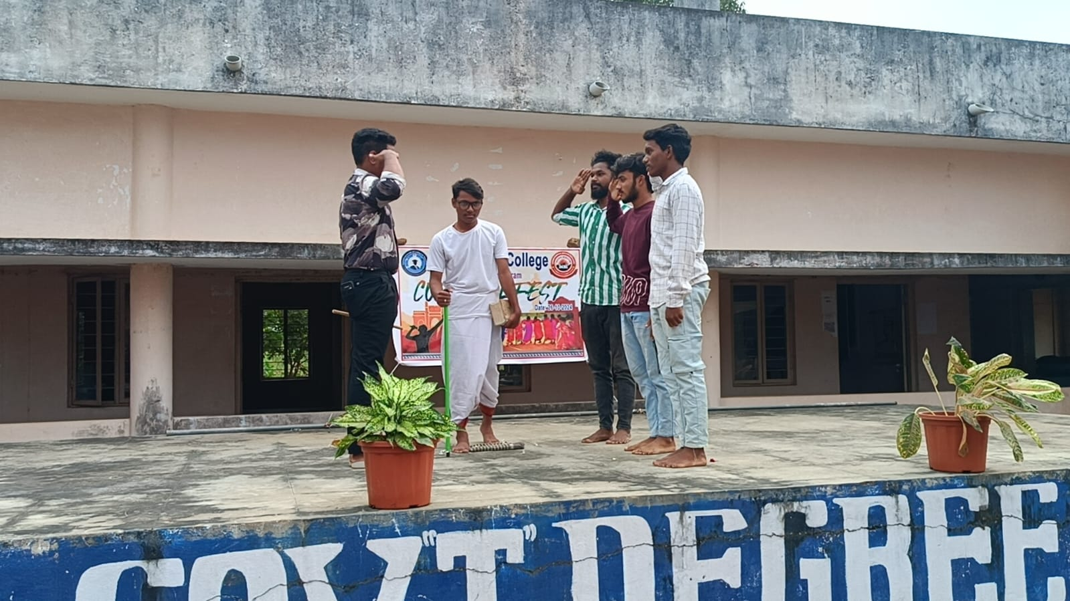

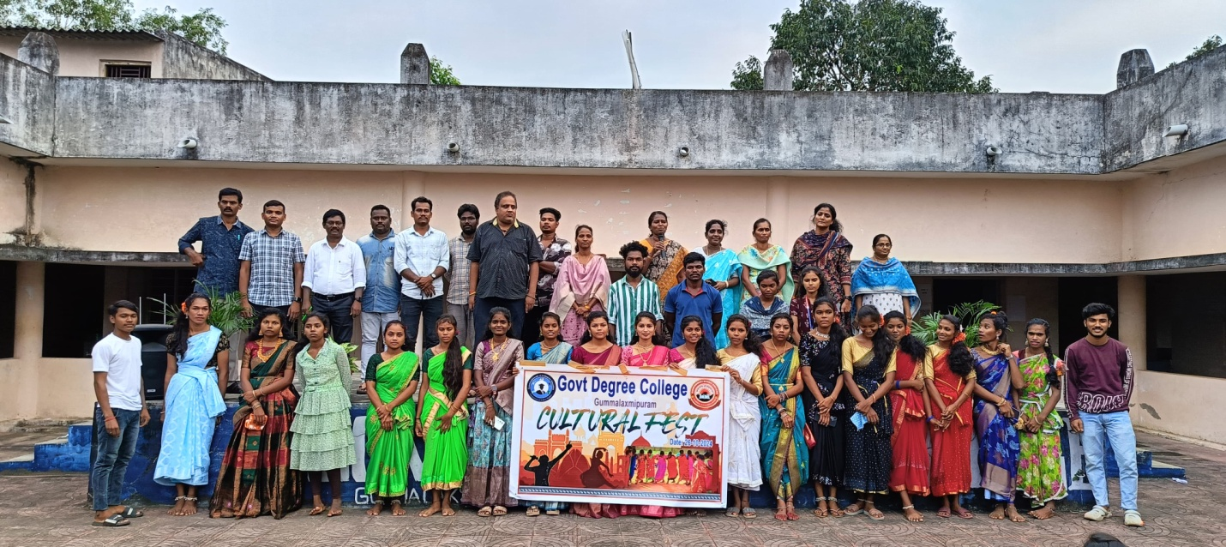

**Impact and Outcomes:**

* The Cultural Fest proved to be a **platform for talent recognition and appreciation**, as well as a means of building **confidence, coordination, and camaraderie** among students.
* Students got the opportunity to perform before a large audience, enhancing their **communication and presentation skills**.
* The performances helped preserve and promote **local and classical art forms**, enriching the cultural understanding of the student community.

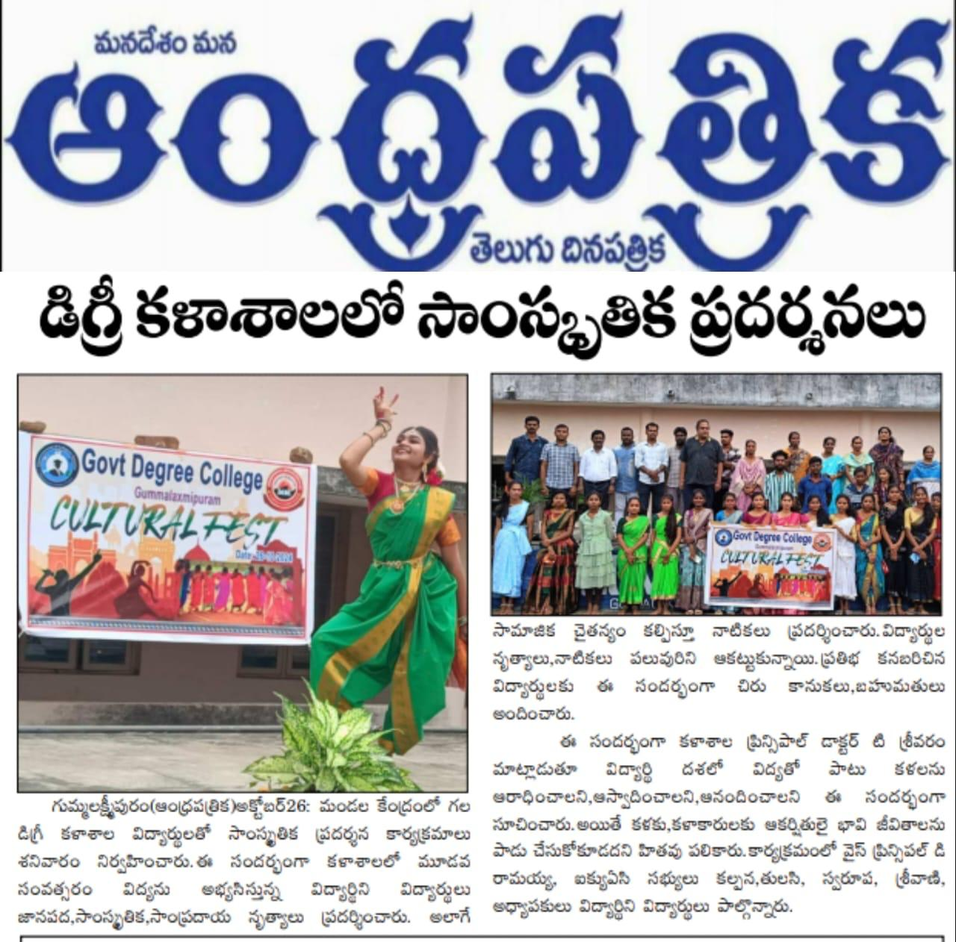

**Conclusion:**

The **Cultural Fest 2024** was a **grand success**, thanks to the **collective effort** of the NSS volunteers, faculty members, and student participants. It created a **joyful and inspiring atmosphere** in the college and highlighted the importance of cultural education in holistic student development.

The NSS Units I & II extend heartfelt gratitude to **Dr. T. Sreevaram, Principal**, all the lecturers, supporting staff, and students who contributed to making this event a resounding success.